Swachhta Pakhwada (15/10/2018 to 31/10/2018)

Plantation:A plantation drive was carried out during the Swachhta Pakhwada (15.10.2018 to 31.10.2018)in different schools across fourteen districts of the State of Punjab. It was consciously decided that the tree plantation drive would be carried out in schools so as to encourage & educate children about benefits of tree plantation.

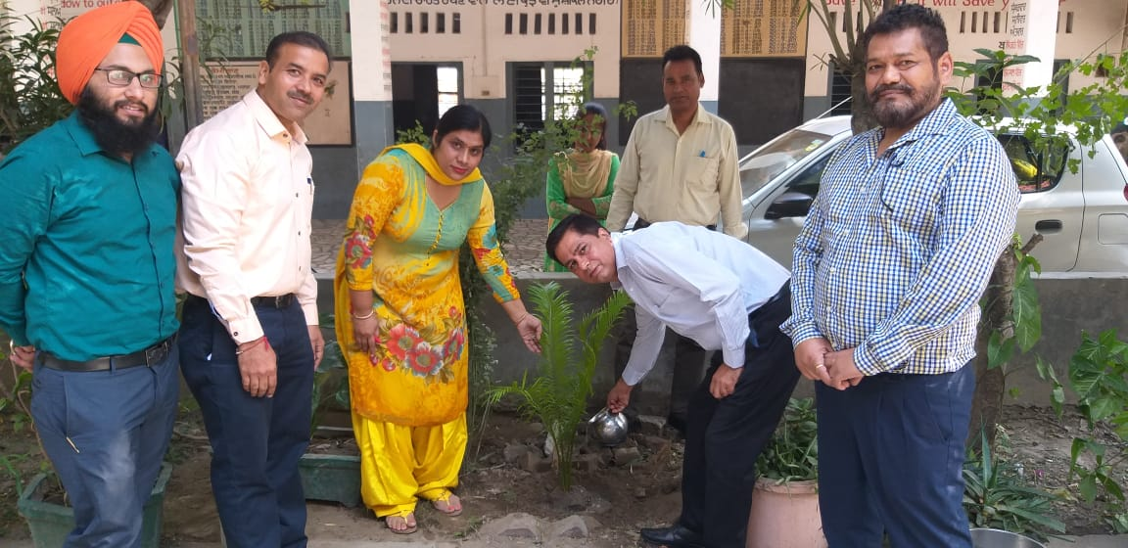

Tree Plantation at Govt. Middle School No 5, Civil Lines, Ludhiana

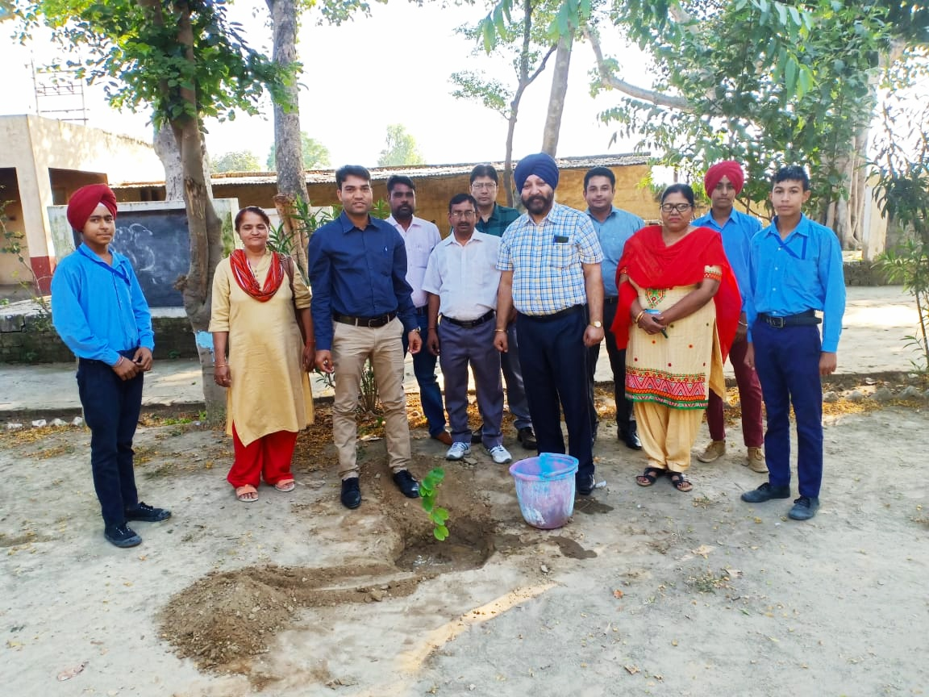
Tree Plantation at Govt. High School, Salaudi, Khanna

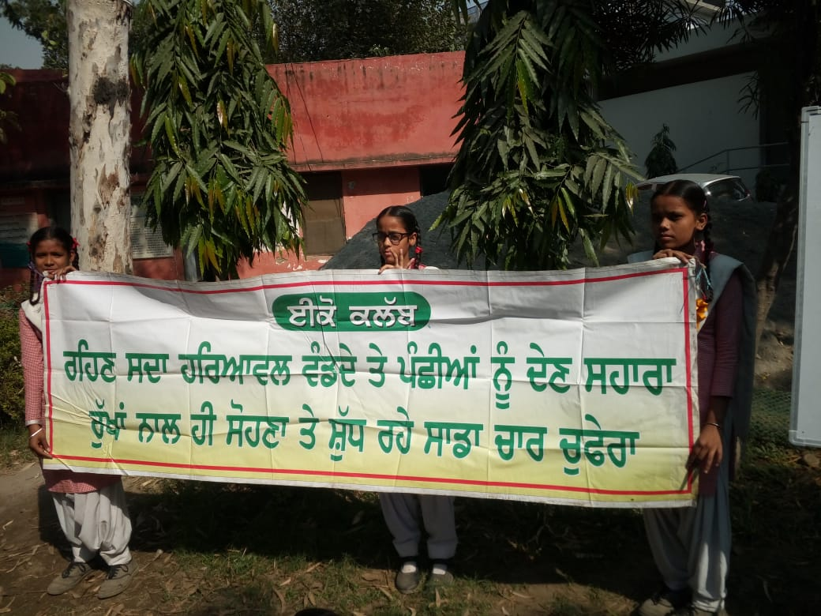
Tree Plantation at Govt. Sr. Sec. School DhandriKalan, Ludhiana

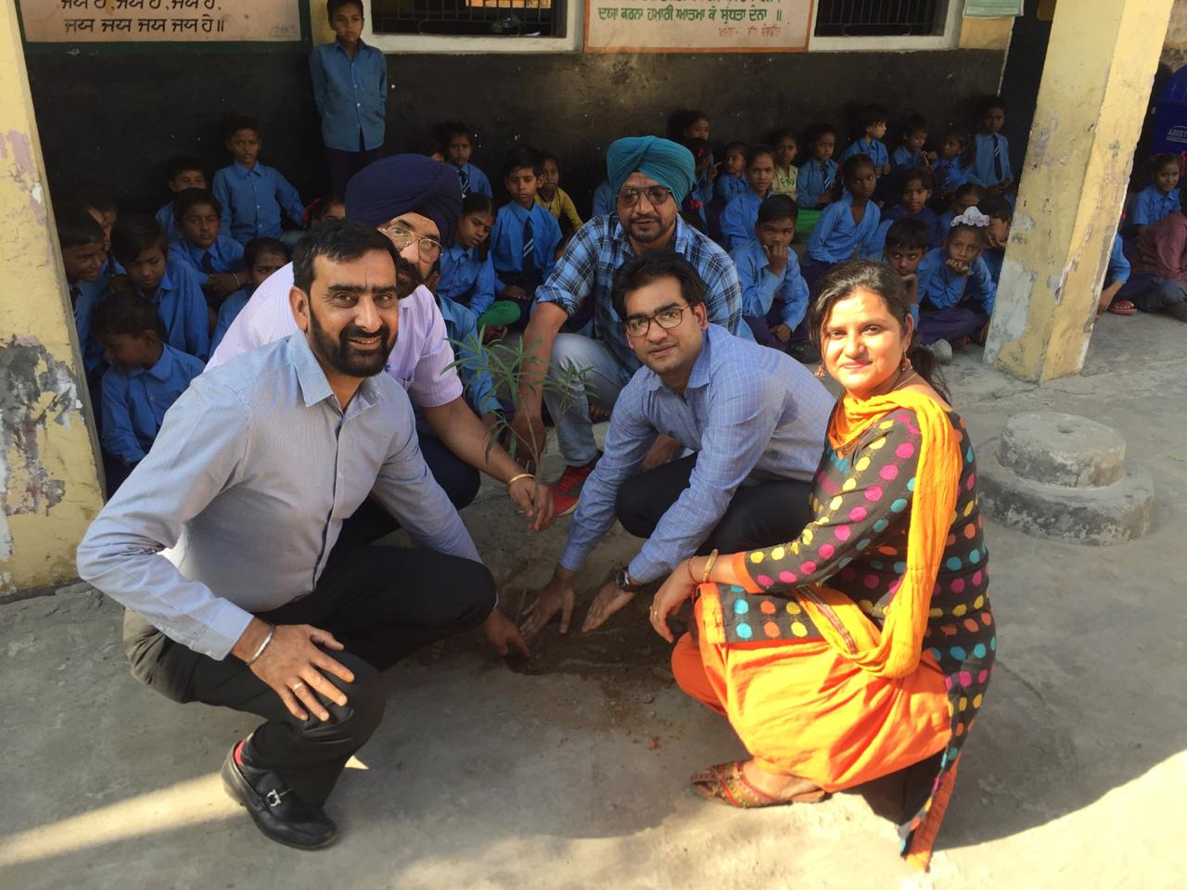

Tree Plantation at Govt. Elementary School, PremNagar,Mandigobindgarh

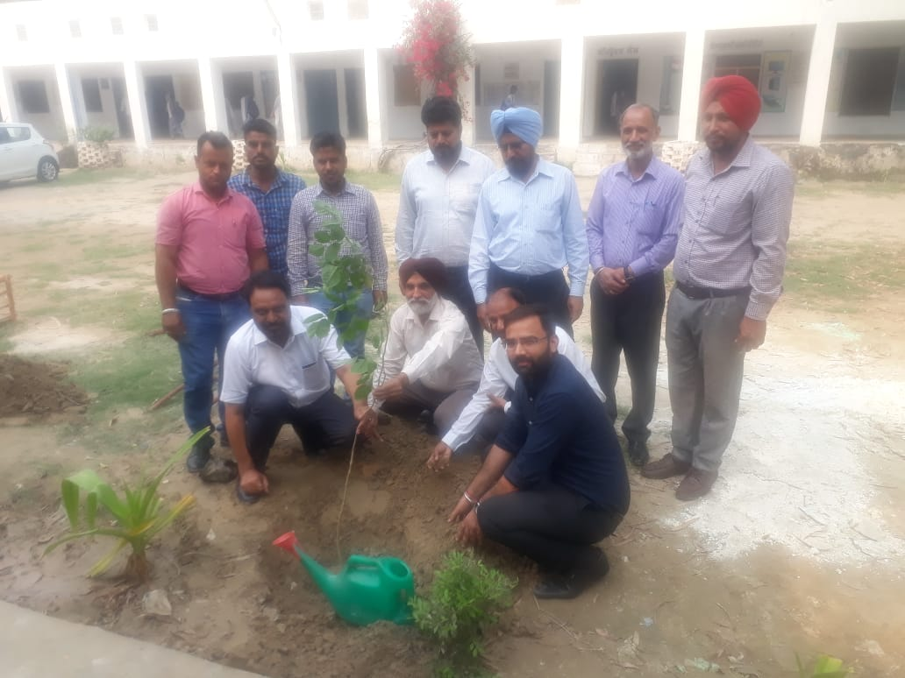
Tree Plantation at Govt.Sr.Sec. School, BhuchoMandi, Bathinda
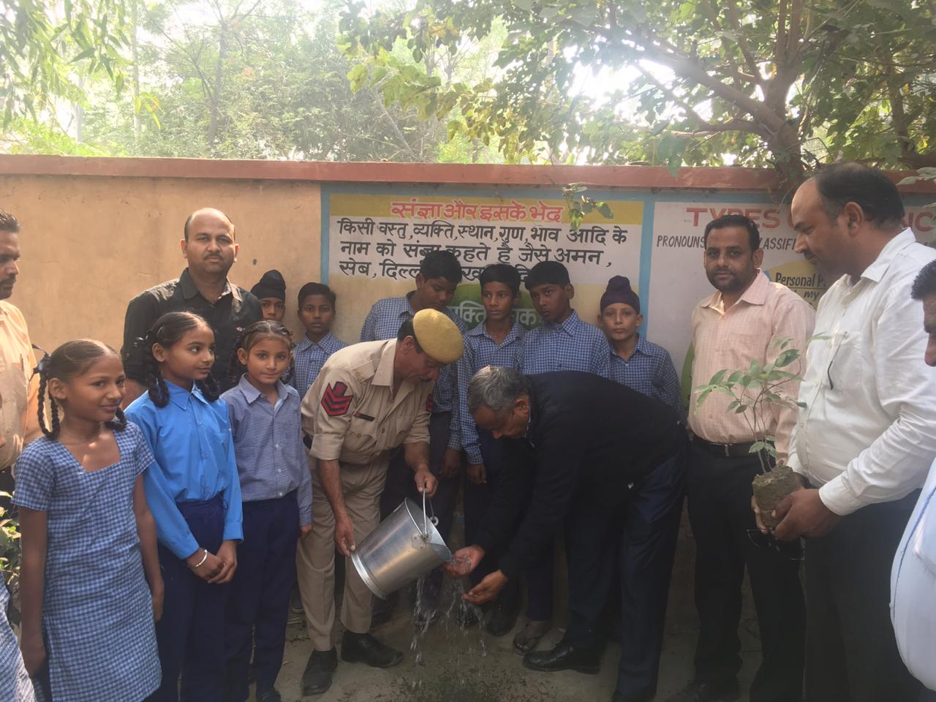Tree Plantation at Govt. Primary School, Dhiraghara Ferozepur

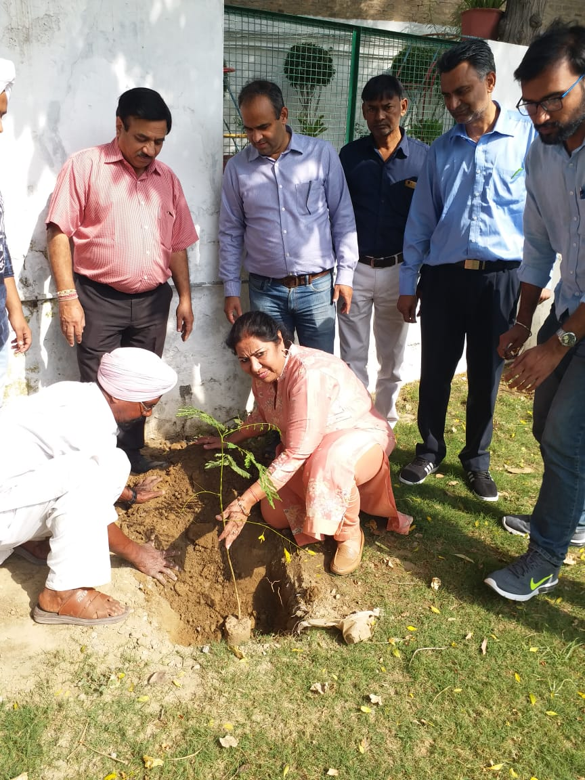
Tree Plantation at S.D. Model Sr. Sec. School, Moga

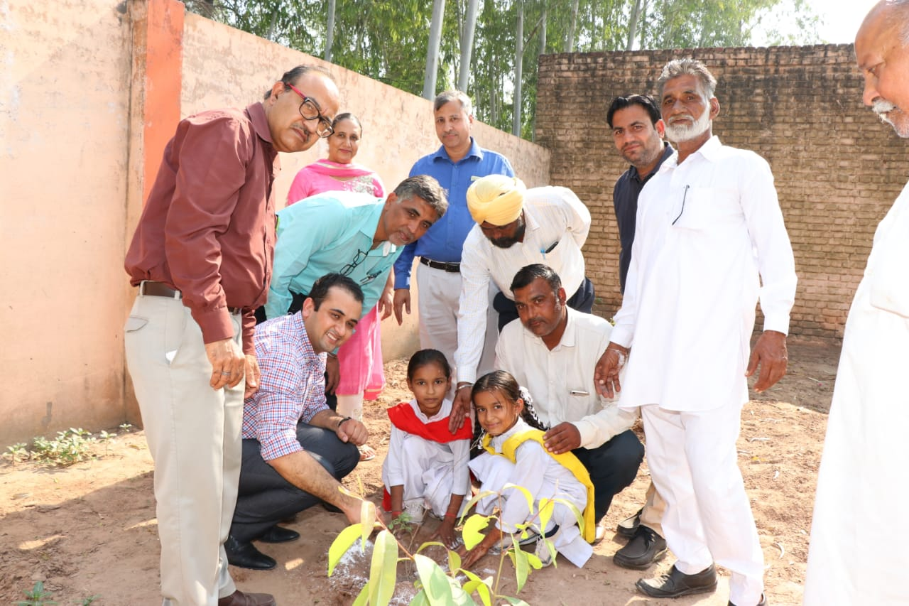Tree Plantation at Govt. Sr. Sec. School, Ullana, Patiala

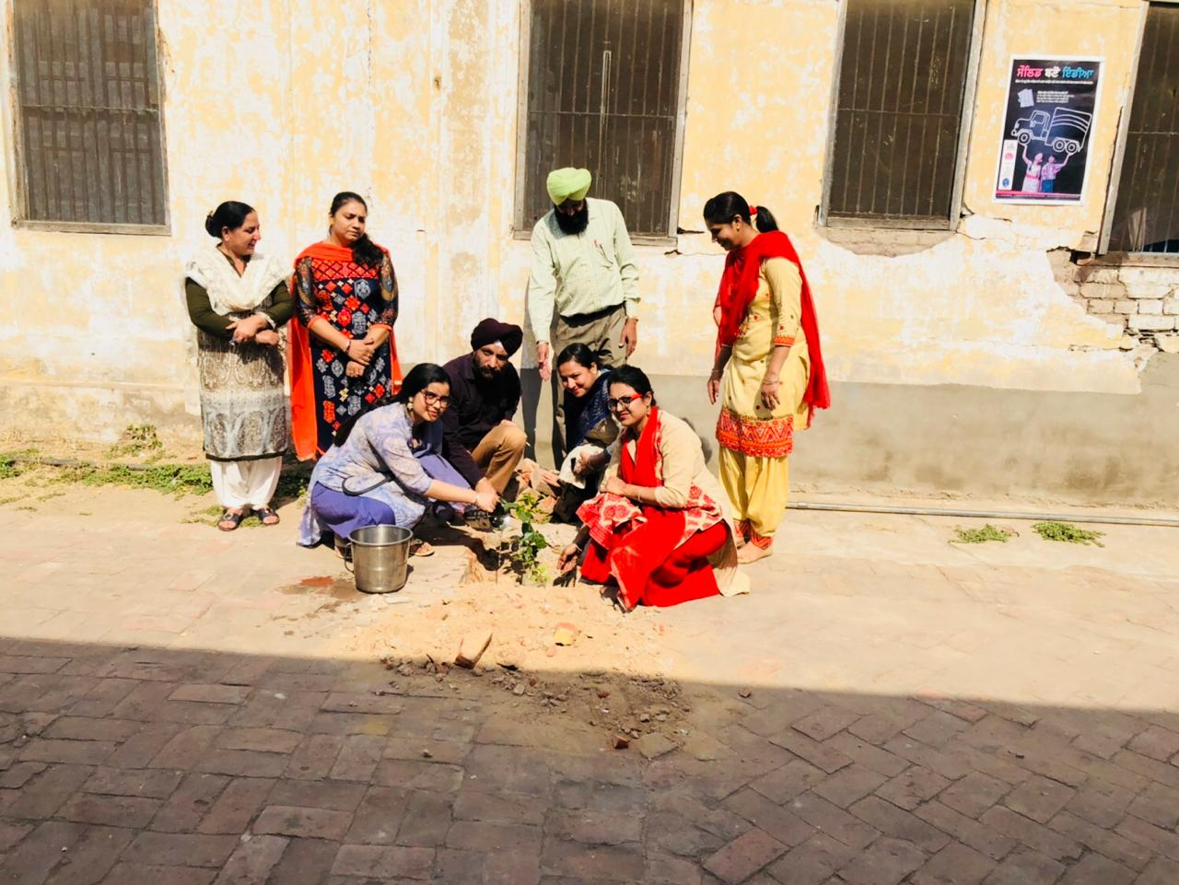
Tree Plantation at Govt. Primary School, Samana, Patiala

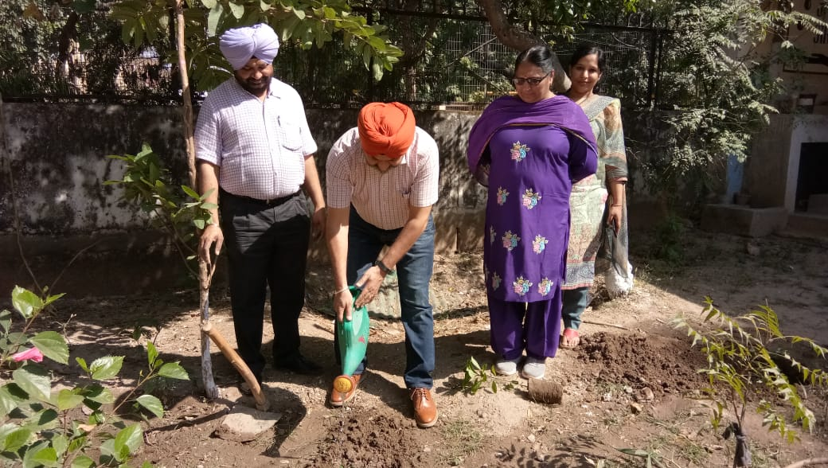
Tree Plantation at Govt. High School, Phase V, Mohali

